***PAAREES PERFUMES***

***THIERRY MUGLER***

***FOR WOMEN***

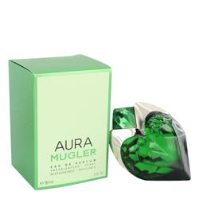

# 

***MUGLER AURA***

## *Description:*

Mugler Aura by Thierry Mugler Perfume. Mugler Aura is a refreshing and floral perfume that was introduced in 2017. It is described by the brand as a scent that will help you ‘to reconnect with your inner nature and to unleash all your femininity and your aura.’ This feminine fragrance is versatile, making it perfect for any occasion. The notes include tiger liana, bourbon vanilla, rhubarb leaf, orange blossom and wolfwood.